TLC analysis of anthocyanins using Forestal

Materials:
- 2M HCl
- Isoamylalcohol
- 2.2ml tubes
- TLC plate cellulose pre-coated: Merck 1.05730
- Capillaries
- Container for running TLC plate
- Running solvent (Forestal) = Acetic acid: HCl 36%: Water = 30 : 3: 10 (Forestal)

Procedure:
- Pick 1 corolla from an open flower and push it on the bottom of a marked 2.2 ml Eppendorf tube and then add 1 ml of 2 M HCl, take care that the material is covered with liquid.
- Put the tube, with closed cap, in boiling water for 20 minutes to hydrolyze the flavonoid-sugar binding (boil in fume hood, beware of HCl fumes).
- Add 150 µl isoamylalcohol and vortex 10 sec. The flavonoids will be concentrated in the isoamylalcohol (top layer).
- Centrifuge for 5 minutes.
- Marking the TLC plate is only possible with a soft pencil.
- Take an aliquot of the isoamylalcohol extract (top layer) in a glass capillary and spot samples on a cellulose TLC plate, approximately 2 cm from the bottom.
- Apply the samples by tapping the capillary on the cellulose 3-4 times very short. Try to keep the spot small. Allow the solvent to evaporate. Repeat this once to spot enough material.
- Put the TLC plate for 1-2 hours in a TLC container with the running solvent, Forestal, until the solvent reaches the top of the plate

Results
When viewed in normal light:
Anthocyanins are visible in normal light as reddish and purple colored spots. From bottom to top three zones can be seen:
- Zone 1: Delphinidin
- Zone 2: Cyanidin and Petunidin.
  - These compounds co-migrate in Forestal, but can be distinguished based on their colors as cyanidin has a reddish color and petunidin a more purplish color.
  - The distinction between red vs purple is not so easy. Make sure that you run well defined controls along to recognize what is reddish and what is purplish.
  - In case the tissue accumulates a mix of cyanidin (reddish) and petunidin(purplish) the distinct reddis vs purplish becomes nearly impossible
- Zone 3: peonidin (reddish) or malvidin (purplish)

When viewed under UV light (using a UV transilluminator for DNA gels)
- Anthocyanins are now even better visible (also trace amounts that are hard to see under normal light), though the color distinction reddish/purple is less easy now.
- Flavonols are seen as yellow fluorescent spots.
  - Quercetin is seen in the Zone 2, near the position of cyanidin and petunidin
  - Kaempferol is seen in Zone 3 , near the position of malvidin, peonidin

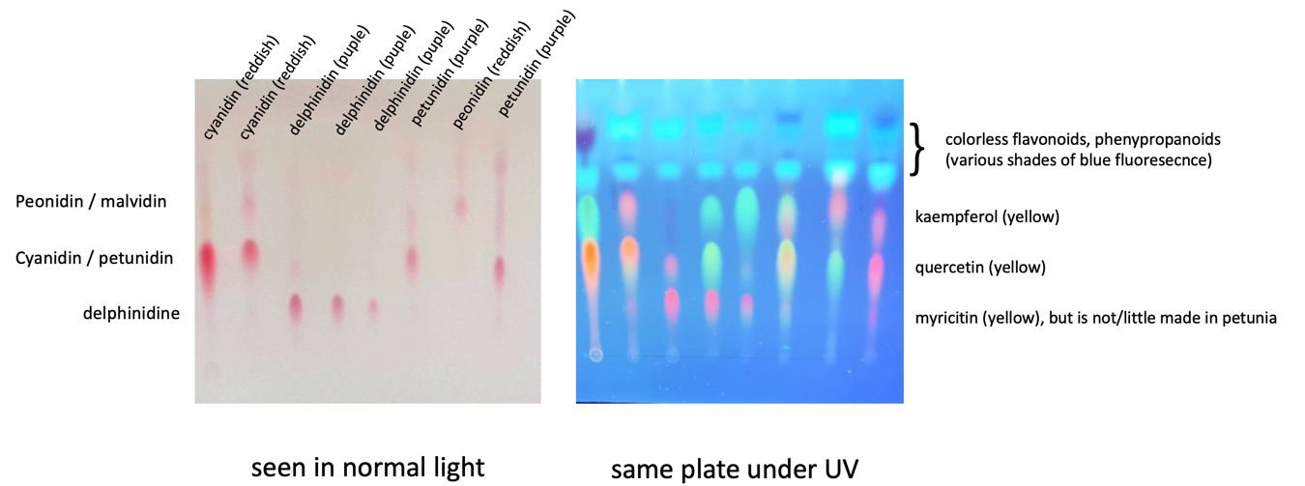
Section of a TLC plate seen in visible light (left) and under UV (on a DNA gel transilluminator). In the left part the nature of the anthocyanins is indicated above the tracks. Note the color difference of the red (cyanidin, peonidin) and purple (delphinidin, petunidin) spots. Right: flavonols (kaempferol and quercetin) light up us a yellow spots. The bluish spots on the top are, amongst others, colorless intermediates of the anthocyanin/flavonols pathway that cannot be unequivocally identified in this system.

2. TLC analysis of anthocyanins using isopropanol-HCl
When analyzing anthocyanin the above procedure (#1) with Forestall as running solvent, is usually the best choice.

In case it is difficult to score the difference between reddish and purplish spots (cyanin vs petunidin) or when dealing with a mixture of the reddish and purplish anthocyanin, you can run the same sample on cellulose plates with Isopropanol HCL as a solvent. This separates reddish (cyanidin, peodnidin) from the purplish anthocyanins (delphinidin, petunidin, malvidin)

Procedure:
- Spot sample on cellulose plates, exactly as described above
- Now use as running solvent Isopropanol-HCl (Water : Propanol-2 : HCl(36%) = 5:6:1)
- After a run in isopropanol-HCl you will see only two zones:
  - zone 1 at bottom: delphinidin , petunidin and malvidin
  - zone 2: higher up: cyanidin+ peonidin

3 TLC analysis of colorless panthocyanin and falanol recursors
For separation of colourless intermediates: use TLC plates Silicagel 60 F254(Merck 1.05729):

- Extract flavonoids intermediates by boiling tissue in 2 M HCl as described above (step1-2).
- Extract with ~150 µl ethylacetate.
- Apply on Silicagel 60 F254 (Merck 1.05729): only 1-2x tapping is sufficient
- Run plates in CHCl₃:methanol:HCOOH=90:9:1 (this goes very fast and is done in 15-30 min)
- View under UV light (DNA transilluminator works fine). UV absorbing compounds are now visible as dark spots on a green fluorescent background.

To identify the nature of the various compounds run known (pure) compounds as markers in separate tracks

Real life examples (taken from old publications)

From Koes et al PNAS 1995

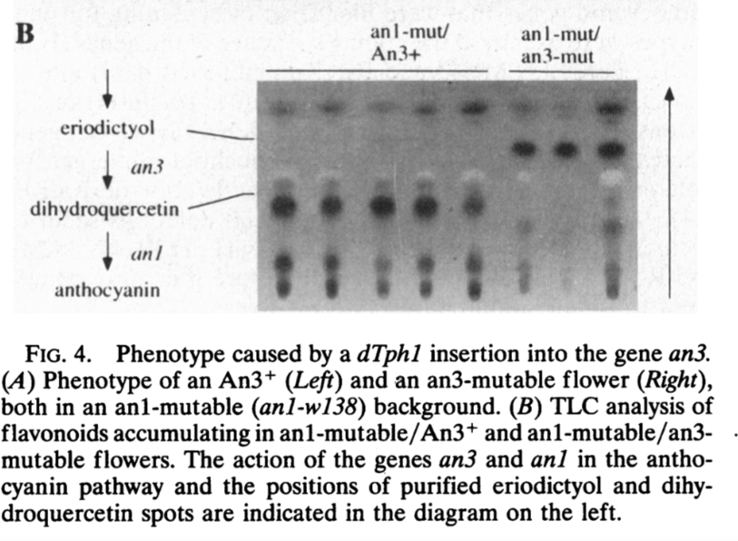

From van Tunen et al Plant Cell (1991)

